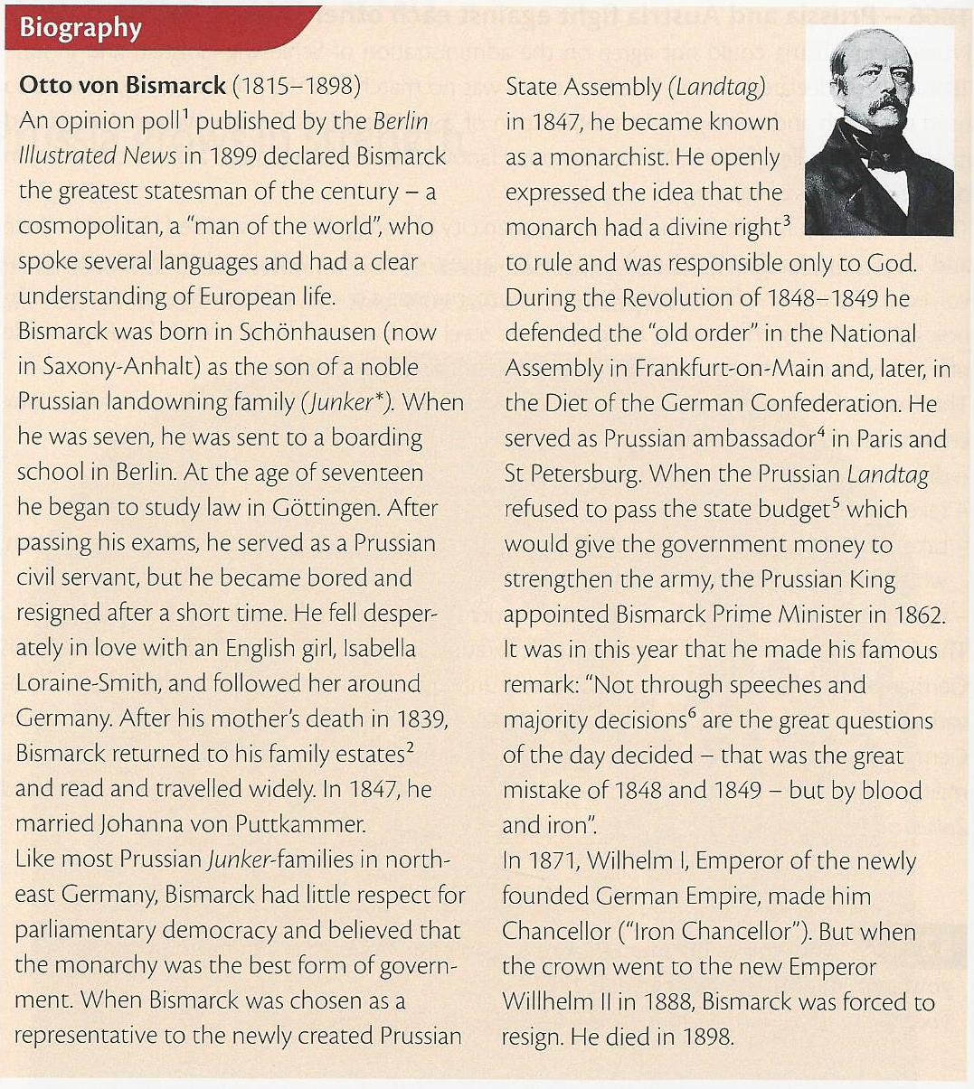

Germany after the failed Revolution
The disaster of the failed revolution of 1848 did not mean that the idea of Geman unification was forgoten in the German states. But it remained a dream until the Prussian Kin Wilhelm I (1858-1888) appointed Otto von Bismarck Prime Minister (Ministerpräsident) in 1862. In only nine years after his appointment and thirteen years after the failed revolution, he strengthened Prussia, ended Austria’s influence over German affairs and unified Germany.
1864 – Prussia and Austria together against Denmark (German-Danish War)
The duchies of Schleswig and Holstein were largely settled by Germans and were part of the German Confederation, though they had been ruled since the Middle Ages by the King of Denmark as duke. When he tried to annex the two duchies and turn them into a part of Denmark, Bismarck saw his first chance to act. He provoked Austria to declare war on the militarily weak Denmark and to take control of the two territories. After a short war fought with a combined Prussian and Austrian army, Prussia occupied Schleswig and Austria took over Holstein.
1866 – Prussia and Austria fight against each other (Austro-Prussian War)
Prussia and Austria could not agree on the administration of Schleswig-Holstein and in June 1866, Austria declared war on Prussia. Austria was no match for the Prussian army, which used telegraph and railways in its mobilization of 250,000 soldiers. Prussia overran Austria and its six German Allies (Bavaria, Nassau, Saxony, Hanover, Hesse-Kassel, and Frankfurt-on-Main) in only seven weeks of fighting.
The battle on 3 July 1866 for the former Austrian city of Königgrätz – now called Hradec Králové and located in the Czech Republic – was the largest of its time, with nearly 500,000 troops involved. It was also the first battle where the outcome was a direct result of the use of new weapons and

technologies, including the railway and the telegraph. The losses in the battle were immense on both sides.
The Treaty of Prague of August 1866 officially ended the war and changed the map of Germany enormously. Prussia managed to:
- dissolve the German Confederation of 1815;
- take control of both Schleswig and Holstein;
- take control of and annex, against all international law, the German states north of the Main, which had fought on the Austrian side;
- form the North German Confederation (Norddeutscher Bund) under Prussian control – and without Austria.
The founding of the North German Confederation marked the end of Austrian influence in Germany. Bismarck’s aim had been archieved. Only the German states in the south such as Bavaria, Baden, Wurtemberg and Hesse-Darmstadt remained independent. Although these states feared further “Prussinization” in Germany, they also feared France. So they were militarily allied with the new North German Confederation and joined the Prussian-dominated Zollverein.

Tasks:
- Read Otto von Bismarck’s biography. Then copy the chart below and list the important dates in his life, giving information on what happened, and match them with developments and events from German and/or European history.
- Explain the phrase “unification by blood and iron” in your own words.
- Read the text and discuss whether the war of 1866 can be called a German civil war.

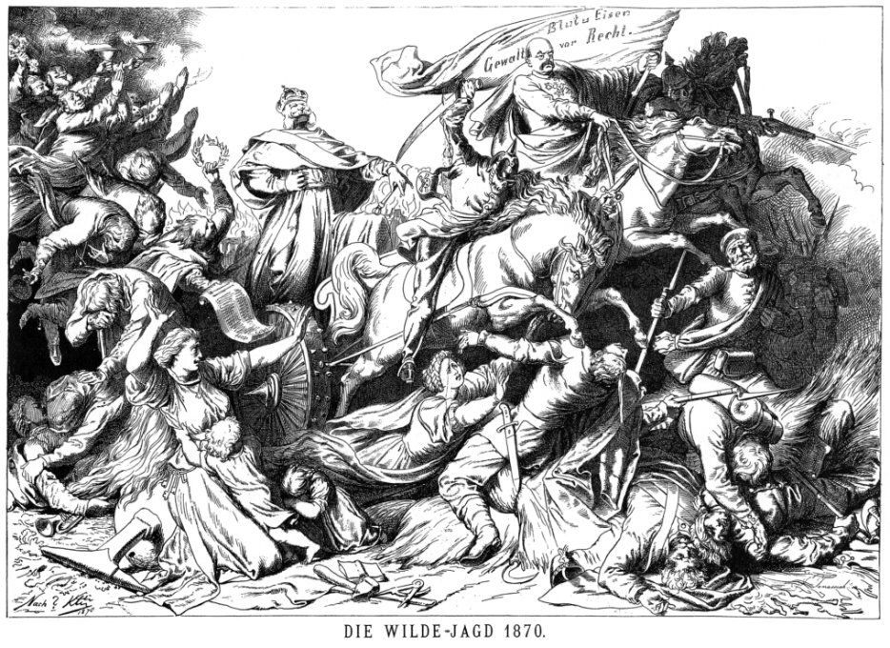
“Die wilde Jagd” (The wild hunt), carton published in the Austrian newspaper Der Floh, December 1870.
The carton shows the Prussian king, Wilhelm I, as triumphant winner in his war chariot (Streitwagen). The driver Bismarck is holding the reins (Zügel) in one hand and a flag in the other which reads: “Force before law”. The two figures on his left and right symbolize death.

Chart task 1
Dates | Bismarck | What happened in German or European history?
1815 | born in Schönhausen in Prussia | Waterloo, Congress of Vienna

